**Assignment 3**

1. Implement transpose of a given matrix

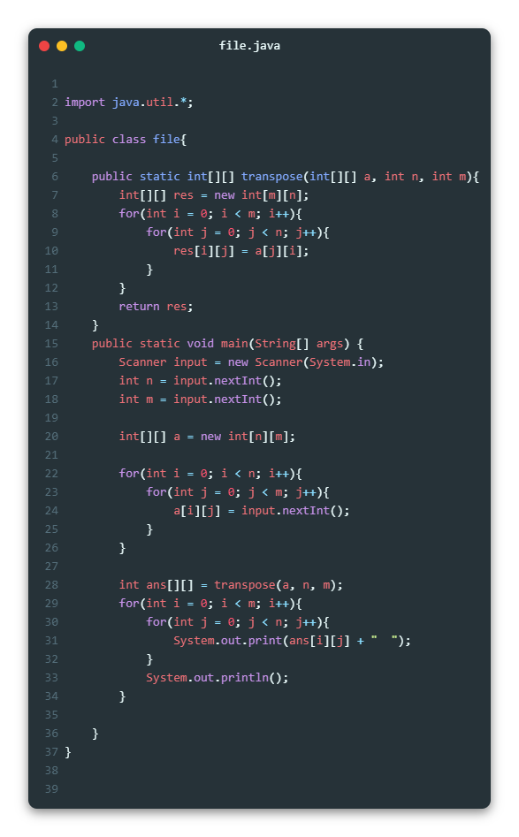

1. Implement multiplication of two Matrix

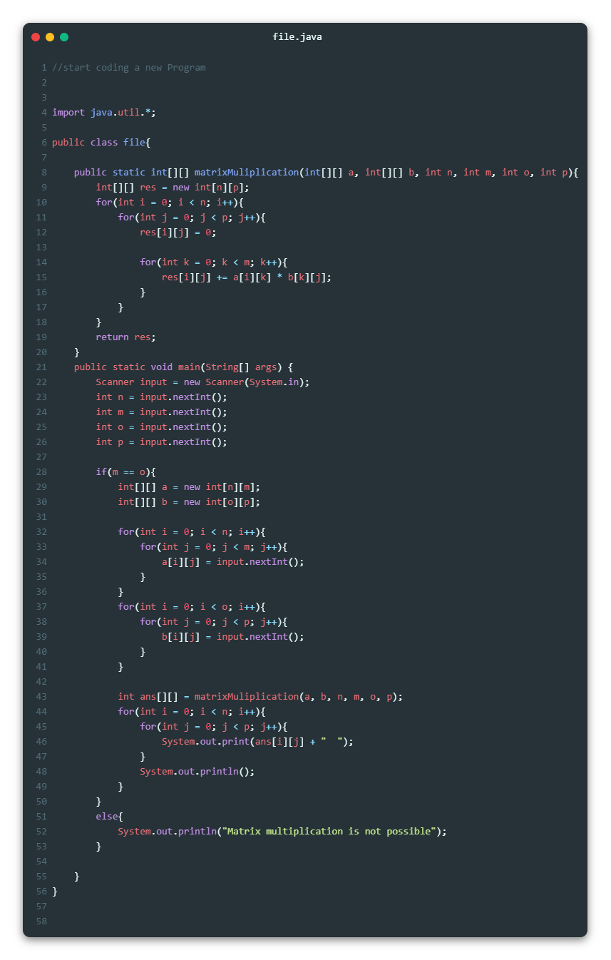

3. Implement a program to generate random password based on

customer name, age and id for banking applications

